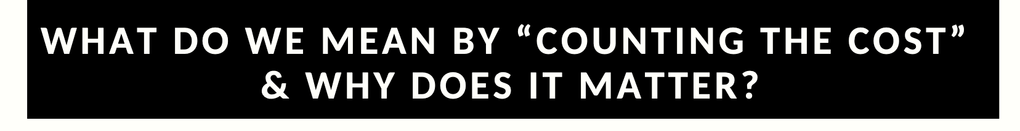

NARRATIVE REFLECTION WORKSHEET

Identify an event, idea or policy related to suffering in your organization or ministry:

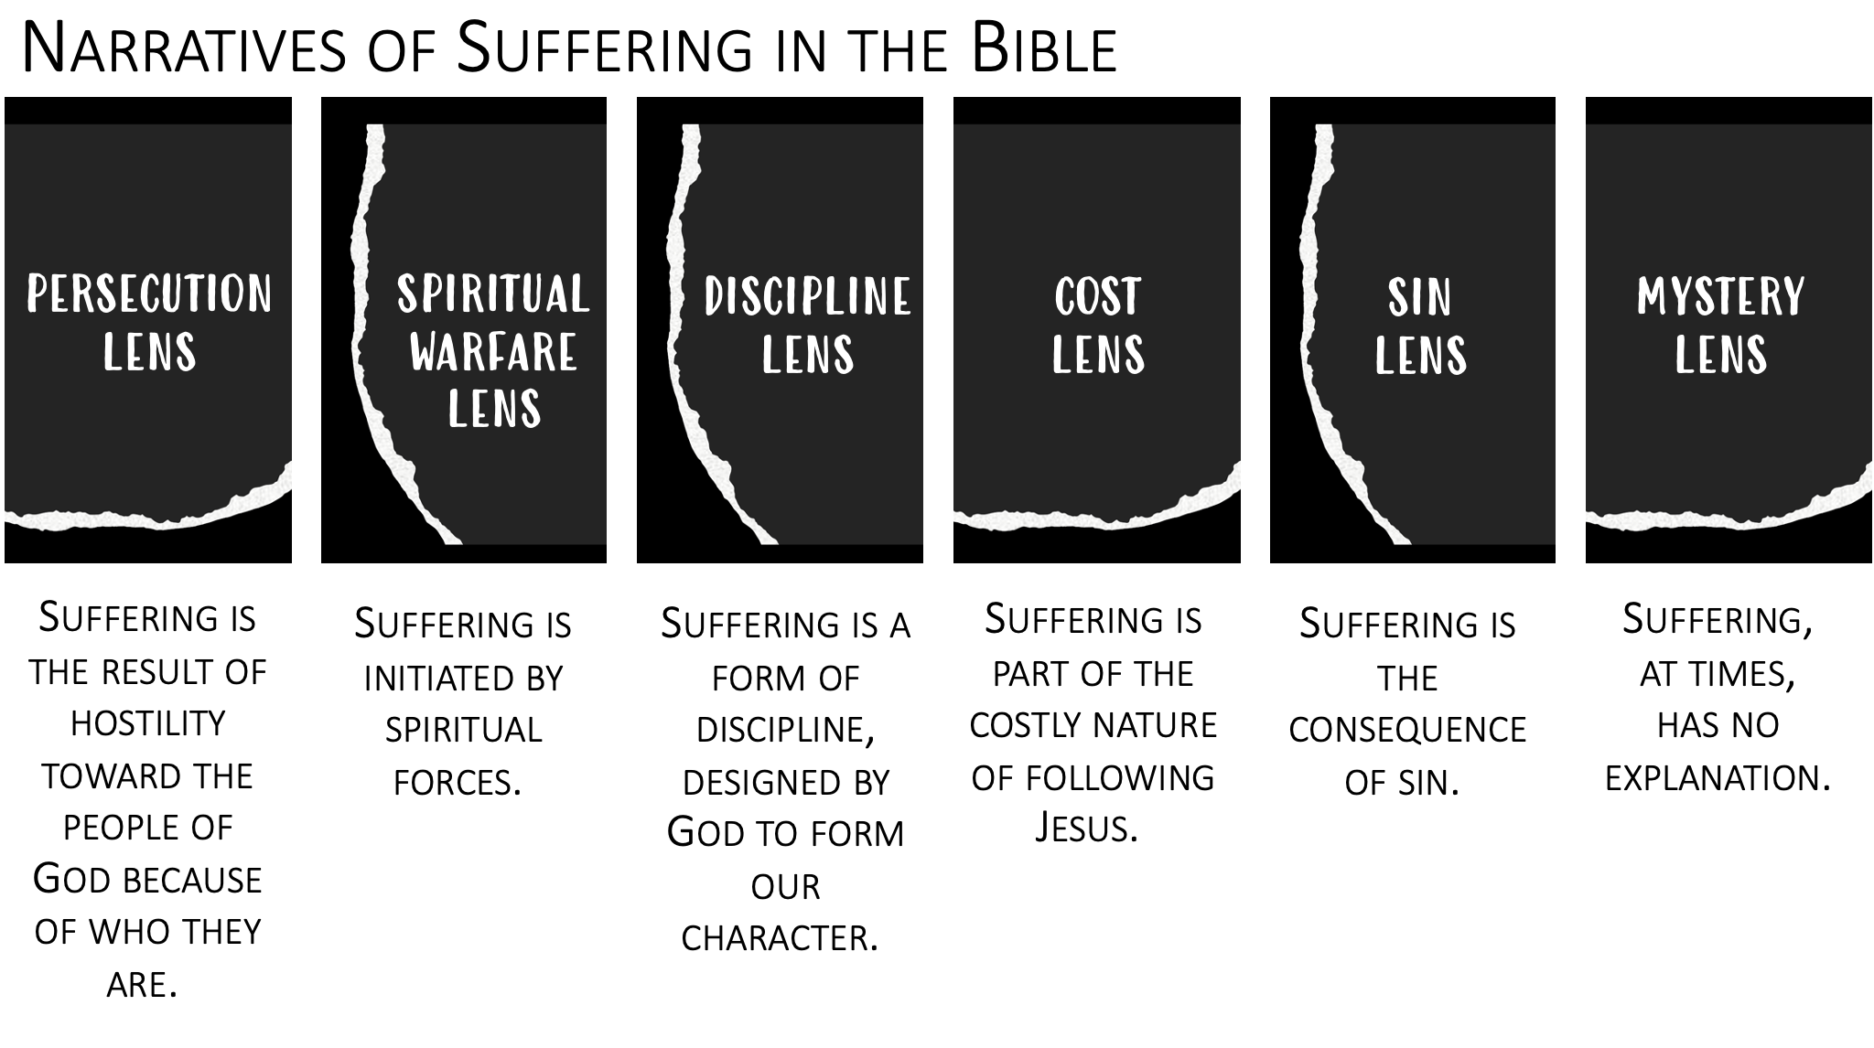
- Take time to consider what narratives are present in this situation.
Are there any connections to narratives discussed in the bible or elsewhere?
How has this idea or policy developed? (If it is an event, how is it being approached?)
What key voices are shaping these narratives?
What voices need to be included?

- Identify the deeper questions these narratives raise.
What makes these narratives important to you?
What are these lenses keeping you from seeing?
What is at the heart of these narratives?

- Consider the implications of these narratives.
Do they highlight anything that is unresolved in you or your organization?
Do they open any new possibilities?

- Choose your way forward.
What you need to spend more time with?
Who needs to be part of this conversation?
How will this decision shape you? Your context?
What specific actions do you want to take? Who can help?

What are you noticing as you engage this process?

This process and these questions are based on:
Cunliffe, A. (2004) ‘On Becoming a Critically Reflexive Practitioner’, Journal of Management Education, 28(4), pp. 407–426.

